JASMIN M. DIMARANAN  Tagapamahala | Petsa | ATTY. MICHELLE C. BORROMEO  Tagapamahala, BOD | Petsa
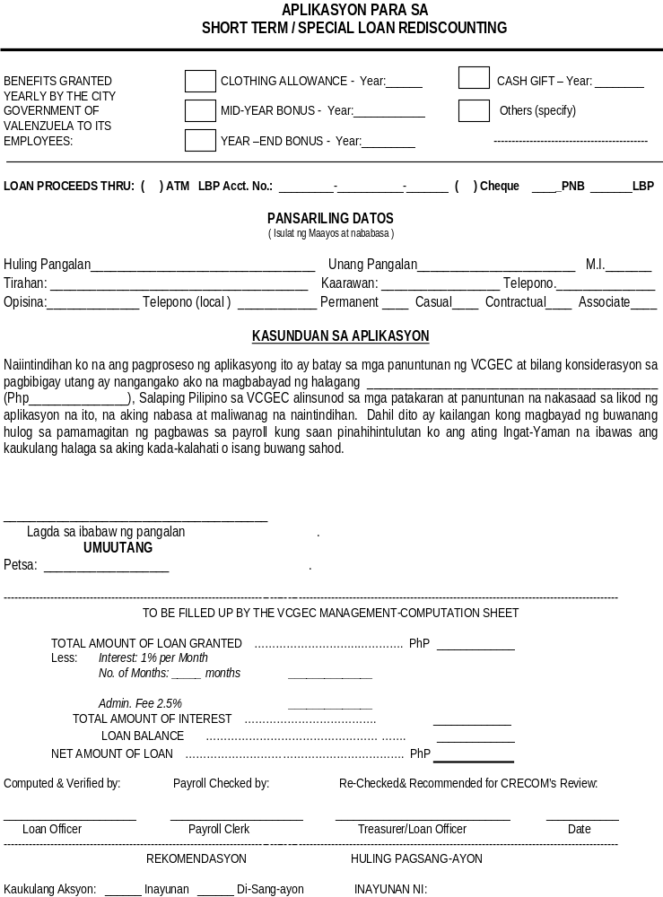

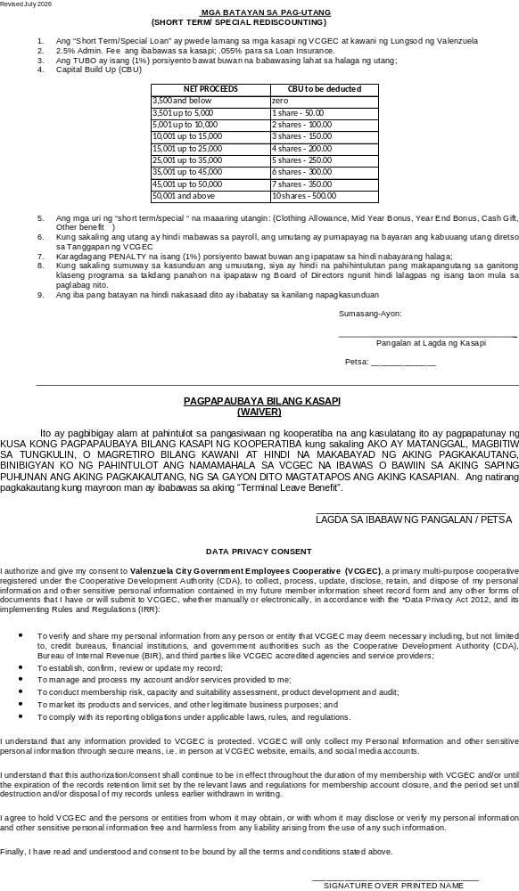

__________________
DATE
ATTY. MICHELLE C. BORROMEO
Chairperson, Board of Director
Valenzuela City Government Employee Cooperative (VCGEC)
Dear Maam:
Good day!
May I request from your good office to allow the undersigned to avail the rediscounting of my
__________________________________________________.
Net proceeds will be used for (State reason of request):

Your kind consideration and approval of my request is very much appreciated.
More power to VCGEC and God bless us all
Very truly yours,
_______________________________________
SIGNATURE OVER PRINTED NAME OF MEMBER
APPROVED BY:
ATTY. MICHELLE C. BORROMEO
BOD Chairperson VCGEC
lra

